**PROJECT REPOT**

**1 INTORDUCTION**

1.1 OVERVIEW

In this project, we make the analysis of Data set of Indian Agricultural Crop Production . It had a lot of state’s details and we interpreted it, with the help of the Tableau from the given two different types of Data sets.

Tableau is an end-to-end data analytics platform that allows you to prep, analyze, collaborate, and share your big data insights. Tableau excels in self-service visual analysis, allowing people to ask new questions of governed big data and easily share those insights across the organization.

1.2 PURPOSE

To check whether the improvements of the Agricultural developments of different types of states in a particular year. We used the Piechart and Barchart for making the analysis of the certain Dataset (i.e) Sales, Areas etc., in various types of spread sheets in the Tableau website.

Data analytics helps individuals and organizations make sense of data. Data analysts typically analyze raw data for insights and trends. They use various tools and techniques to help organizations make decisions and succeed.

Toggle between the Data pane and the Analytics pane by clicking the tabs at the top of the side bar. For more details, see Apply Advanced Analysis to a View (Analytics Pane).

**2 PROBLEM DEFINITION & DESIGN THINKING**

2.1 EMPATHY MAP

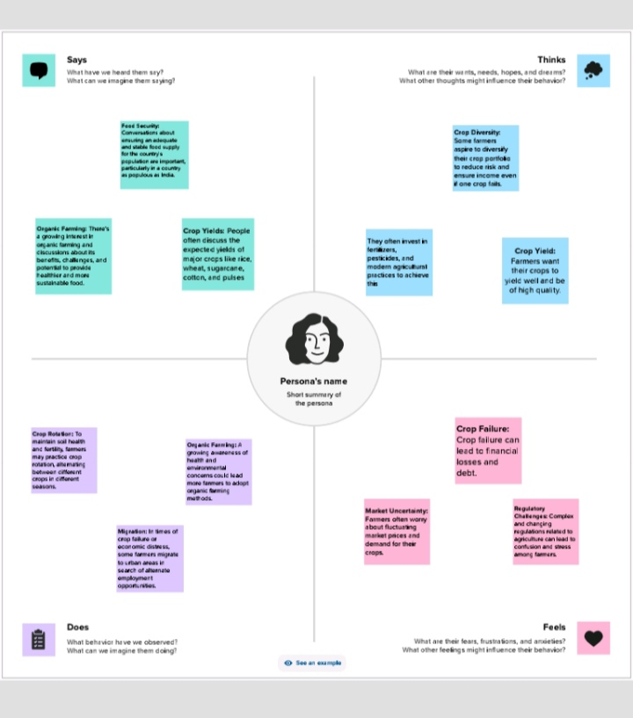

With increased digitization, there’s an opportunity and need for business leaders to reassess the data literacy support provided to their workforce. In turn, they will reduce the data skills gap and advance their organization’s analytics maturity.

**2.2** IDEATION & BRAINSTROMING MAP

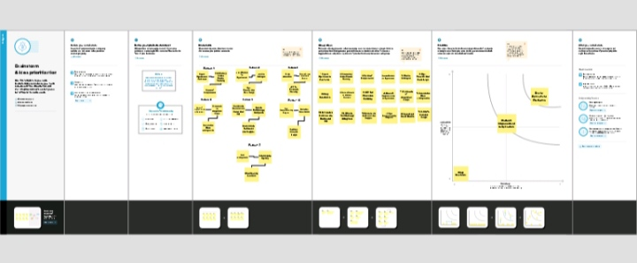

Tableau helps people and organizations be more data-driven as the market-leading choice for modern business intelligence, our analytics platform makes it easier for people to explore and manage data, and faster to discover and share insights that can change businesses and the world.

**3 RESULT**

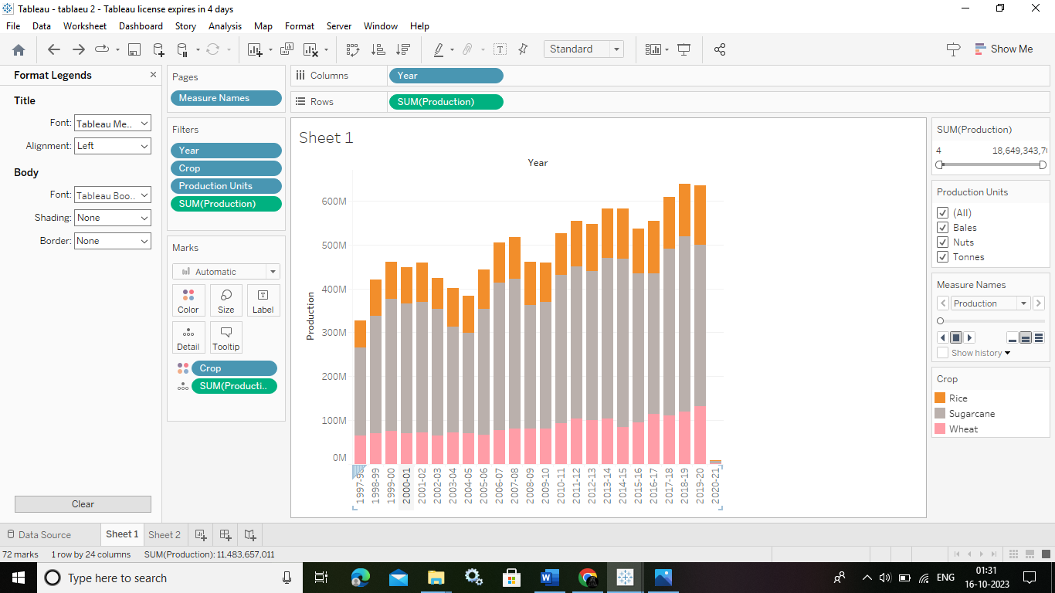

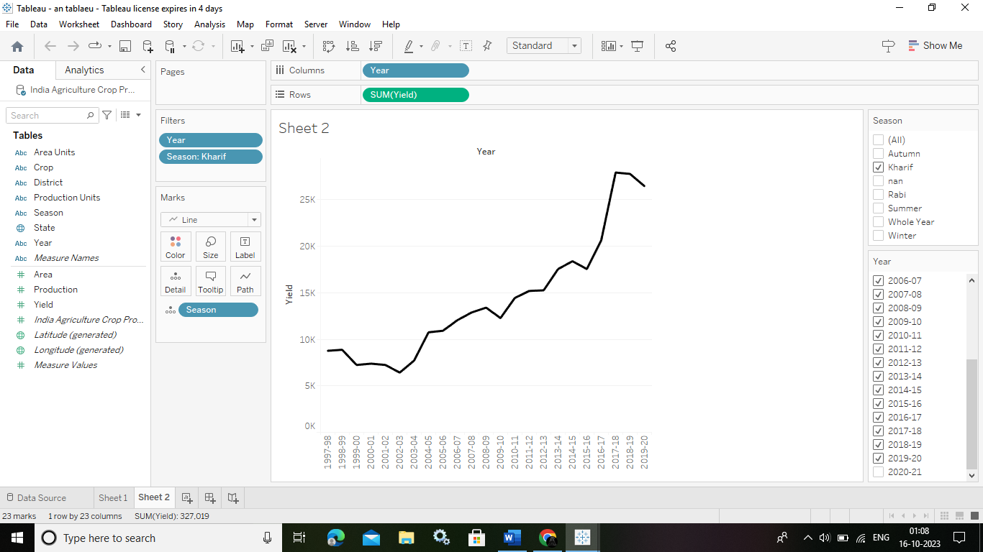

**4 ADVANTAGES & DISADVANTAGES**

**ADVANTAGES :**

Millions of rows of data can be handled with efficiency via Tableau. Large amounts of data can be used to generate a variety of visualizations without compromising the dashboards' performance. Additionally, Tableau has a feature that allows users to create “live” connections to other data sources, such as SQL, etc.

Building dashboards with Tableau allows even non-technical users to create interactive, real-time visualizations in minutes. In just a few clicks, they can combine data sources, add filters, and drill down into specific information.

Data visualization is one of the most important capabilities of any business intelligence (BI) and analytics solution. It helps people translate complex data into a visual context, like a chart or a graph, identify trends numbers alone can't easily reveal, and discover hidden patterns in your dashboard.

As the market-leading choice for modern business intelligence, our analytics platform makes it easier for people to explore and manage data, and faster to discover and share insights that can change businesses and the world.

One of the main advantages of Tableau is its ease of use. You don't need to have any coding or programming skills to create stunning and informative dashboards, charts, maps, and stories with Tableau. You can simply drag and drop data sources, fields, filters, and visual elements to customize your views and analysis.

**DISADVANTAGES :**

* Poor Versioning. ...
* No Automatic Refreshing of Reports: ...
* Need Manual Effort: ...
* Not a Comprehensive Solution. ...
* No Version Control: ...
* SQL Knowledge.

Joins may sometimes produce missing or unmatched data fields. - Joins cannot be used on published data sources. - The fields being joined must be of the same data type. If the data type is changed after the join, the join will break.

**5 APPLICATIONS**

It helps users create different charts, graphs, maps, dashboards, and stories for visualizing and analyzing data, to help in making business decisions. Tableau has a lot of unique, exciting features that make it one of the most popular tools in business intelligence (BI)

Tableau can handle large volumes of data quickly. It is faster and provides extensive features for visualizing the data. Tableau doesn't limit the number of data points in visualization or enforce row or size limitations, giving you a 360-degree view of your data.

Business stakeholders commonly use Tableau to see standard KPI reporting for marketing, sales, and customer success. Especially since Salesforce Data Cloud brought Tableau's visualizations into the greater fold of their Customer 360 Platform, it's a staple for teams who need quick access to departmental metrics.

People learn faster. Tableau is built on the work of scientific research to make analysis faster, easier, and more intuitive. Analyzing data in a quick, iterative way that provides immediate feedback makes our products engaging, fun, and easy to learn.

Tableau Software (/tæbˈloʊ/ tab-LOH) is an American interactive data visualization software company focused on business.

**6 CONCLUSION**

Tableau is a powerful data visualization tool that can help businesses make better-informed decisions. With its ability to connect to a wide variety of data sources, create interactive visualizations, and perform advanced analytics, Tableau empowers

users to gain insights and drive growth.

Good data visualization should communicate a data set clearly and effectively by using graphics. The best visualizations make it easy to comprehend data at a glance.

Though the dataset is complex or the dataset is very big, in tableau, we can create dashboards very easily and within less time. Tableau is a data visualization tool that can be used across different data-related profiles.

These profiles include Data Engineers, Data Scientists, Data Analysts, and Business Analysts, to name a few .The stage at which Tableau can be used may vary from role to role and project to project.

**7 FUTURE SCPOPE**

A person with knowledge of Tableau can get many roles like data analyst, business analyst, and Tableau consultant. Further, in Business Intelligence, one can get roles like Business Intelligence Analyst, Business Intelligence Developer, and Business Intelligence Manager, all of which are highly paying roles.

Tableau developers have a range of job titles to choose from – computer architect, business intelligence developer, business objects developer, data analyst, etc. Once you become a certified professional in Tableau from a reputable institute, your options are endless.